Department of Tennessee
American Legion CSM Gary W. Crisp Post 289
Boy Scouts of America
Cub Scout Pack 510

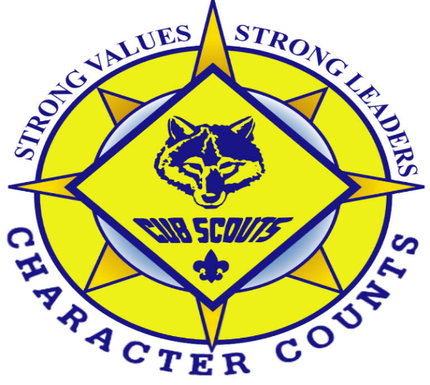

Cub Scout Pack 510
Family Orientation Guide
2019 - 2020
Middle Tennessee Council
Cogioba District

Updated 11-22- 2019

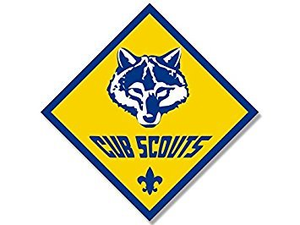

Welcome To
Cub Scout Pack 510
Chartered by the
American Legion CSM Gary W. Crisp Post 289

Dear Scouting Parents:
We would like to welcome you to our pack, pack 510. Cub Scouting BSA offers your children the opportunity to grow physically and mentally, to build character and leadership skills, develop good citizenship traits, and most importantly, have FUN.
Our adult volunteer leaders are devoted to making your child's experience in Scouting one that will be remembered for many years to come. The parents of Pack 510's Cub Scouts are required to participate in the Pack's activities. We have found that this participation acts to strengthen the bond between parent and child. Your participation in the program also provides the Pack with the diversified experiences of its members' parents.
Also, please consider being some type of leader. There are many positions such as den leader, assistant den leader, secretary, pack committee member, activity coordinator, etc., available.
If you ever have any questions about our program or desire to become a registered leader please do not hesitate to contact us. We look forward to sharing the wonderful world of Cub Scouting with you and your children, who will become part of one of our country's finest traditions -Scouting!
Yours in Scouting,

Cubmaster

Cub Scouting and Your Family

The Cub Scout program helps to meet your child growth needs. As kids develop, they have specific development needs such as:

1 To learn new physical skills. They can do this through games, sports, and crafts. As they develop their coordination, they gain a sense of worthiness and acceptance by their peers.
2 To learn to get along with kids in their same age range. He/she needs to form friendships with other children. He/she needs to learn how to balance giving and receiving affection to relate well to their peers. He/she needs to belong to a group of kids their own age. Being a part of a Cub Scout den helps fulfill these needs.
3 To develop their mental processes. They can develop their mental process by reading, writing, and calculating. They need opportunities to use language to express ideas and to influence others. They must move from a preoccupation, with self, to understanding how and what others think of them. Opportunities for observation and experimentation will help them learn self-reliance. Den activities and meetings, along with the advancement program, help them to develop mentally.
4 To develop a value system. He/she is developing a sense of what is right and wrong and what is fair and unfair. They will do this, by cooperating with others, by being taught, by examples from adults, and from positive reinforcement.
5 To develop personal independence. He/she is becoming less dependent on adults. There same-age friends become important to them. In their dens, and in the pack, he/she exercise their independence while learning to get along with others.

Your child also needs to belong to a "group" of children their own age. This group is a key component of the Cub Scout program. A den is like a neighborhood group of six or eight kids in which they will achieve status and recognition.

As you learn more about how Cub Scouting works and what goes on in the den and the pack, you will see that the program helps your child in these five important developmental needs. The uniqueness of Cub Scouting is that you, as their family, join the program with your child. You will help them all along the way.

Important Information

Meeting Times:
Pack/Den Meetings
Usually weekly on a Monday night at Barker’s Mill Elementary School Inside school cafeteria (6:30-7:30)

Pack Activity
Usually once per month as scheduled by the Cubmaster approved by Committee Usually on a Saturday. “check Scout book Events”

Pack 510 Committee Meeting
Usually 6:45 on the Second Tuesday of the month “unless other stated” at a local restaurant All are welcome and is recommended parents and adult leaders attend. all input is welcome
Annual Fees

Pack Dues
$37.50 for the year due at recharter (usually end of October) anything after January is $4 x months left in year.

Boy’s Life
Boys life is a good magazine put out by the BSA for scouts. The Yearly Cost is $12 per year. It is not a requirement to be a scout. only optional

Den Dues
Den dues are $10 a month, starting the first week of September and ending first week of June, $120 a year. Den Dues help the den leaders pay for supplies, to ensure the scouts have the materials needed for advancement. Cubs can pay weekly, or in one lump sum for the year, or it can be taken out of family accounts (if available).

Fundraisers
Scouting can get expensive. So, we are going to try and do 2 fundraisers a year unless they are not needed. We recommend that everyone participate accordingly, however it is not required. Parents may choose to pay for activities and advancements out of pocket. Profits from fundraising activities, will be used to buy equipment, awards, pay for field trips, Pack event supplies etc.

Uniform Requirements

Pack 510 requires that its Cub Scouts and leaders adhere to the official Boy Scouts of America uniform requirements for Cub Scouting. This policy as adopted by the pack committee states that scouts’ uniform should include the standard BSA-issued shirt with BSA-issued trousers or dark blue/green pants/shorts. Cut-off shorts, athletic shorts, or faded or torn blue jeans should not be worn. Adult leaders shall wear the standard BSA-issued shirt. Specific uniform parts and prices are at the Scout Shops. We would like all scouts to have their uniform in the by the first Pack Meeting. There will also be and activity T shirt. prices on that will be determined when order is placed. we hope to keep to about $15.00. During all scouting activities, closed toe shoes should be worn unless otherwise stated for the activity.
Uniform Checklist
All prices are subject to change by the scout shop theses are just estimates.
Uniform
Blue Cub Scout Shirt (Tan Webelo) $24.99 - $44.99
Neckerchief (Den Appropriate) $9.99
` Pants or Shorts (needs to be similar)
Neck slide (Den Appropriate) $5.99
Hat (Den Appropriate) * $14.99
Belt (Den Appropriate) $9.99

Insignia
Council Patch
Pack # 510 $1.49
Den # $1.49
World Crest Emblem $1.49
World Crest Ring $1.49
* optional

Books
Books range in price from $9.99 to $16.99. It would be a good idea to get the cover for the book also. (not required). We recommend getting the book as soon as possible.
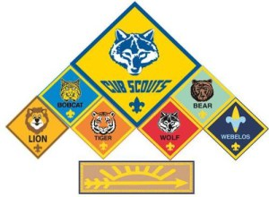

Scout Office & Shop Location

Clarksville Scout Shop
1860 Wilma Rudolph Boulevard, Suite 110 C
Clarksville, TN 37040
(located inside Leap Plaza - park in the back and enter)
Phone:(931) 230-0930

HOURS (May 20- August 10)
Monday, Wednesday and Friday
1:00 p.m. - 5:00 p.m.
Saturday 10 a.m. – 2:00 p.m.
Tuesday, Thursday and Sunday CLOSED
Regular HOURS:
Monday, Wednesday and Friday
12:00 p.m. - 5:30 p.m.
Saturday 10 a.m. – 2:00 p.m.
Tuesday, Thursday and Sunday CLOSED

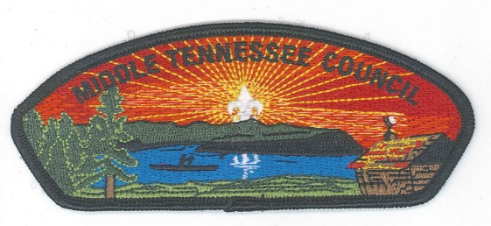
Middle Tennessee Council Office
Jet Potter Scout Service Center
3414 Hillsboro Pike
Nashville, TN 37215
(P) 615-383-9724
(F) 615-297-9916

Cogioba District Staff

Beth Kasper
District Commissioner
bethkasp7781@aol.com
931-387-3715

Brandon Neal
District Executive
bneal@mtcbsa.org
931-337-8316

Glenn Childers
District Chairman
chldrs@msn.com
931-237-1680.

Leader Information

Pack Committee Chairman –
Email:
Phone:
Cubmaster –
Email:
Phone:
Lion Den Leader -
Email:
Phone:
Tiger Den Leader –
Email:
Phone:
Wolf Den Leader –
Email:
Phone:
Bear Den Leader –
Email:
Phone:
Webelo 1 Den Leader
Email:
Phone:
Arrow of Light Den Leader –
Email:
Phone:
Charter Organization Representative
Email:
Phone:

Scout book
Scout book is a web application designed for mobile devices. Scout book delivers a suite of easy-to-use Web-based tools that are helpful to Scouts, parents and unit leaders. It enables units to better communicate, update records, track advancement and manage activities.
ScoutLander
Our Pack web site is located here, please log in and update your family and scout’s information. This site has many pages and lots of good information about Cub Scouting.
http://pack510clarksville.ScoutLander.com
Youth Protection

The Boy Scouts of America places the greatest importance on creating the most secure environment possible for our youth members. To maintain such an environment, the BSA developed numerous procedural and leadership selection policies and provides parents and leaders with resources for the Cub Scout, Boy Scout, and Venturing programs.

Pack 510 requires that any adult that has contact with the scouts needs to take youth protection. This needs to be done as soon as possible. Must be done before the first overnight activity. Please Print out certificate and give it to your den leader or the Cubmaster.

To take Youth Protection training go to My.Scouting.org and create an account. You’ll receive an email notification with your account information, including a member ID/reference number.

The Pack Adult Committee
Our Council: Middle Tennessee Council
Our District; Cogioba District

Our District Executive.
Our District Commissioner: Mrs. Beth Kasper
Our Unit Commissioner: Mrs. Jean Vargas

Our Charter Unit is American Legion CSM Gary W. Crisp Post 289
Charter Organizational Head: Commander David Zeveny
American Legion Department of Tennessee Charter Organizational Representative: 2nd Vice Commander, Ernest A. Schmidt
American Legion Post 289 Scouting Charter Organizational Representative: Mr. Red Kirby
Pack Committee Chairman: Ernest A. Schmidt
Cubmaster:

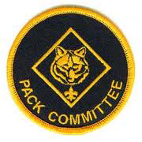

THE PACK 510 COMMITTEE

The Committee Chairman: Ernest A. Schmidt
Secretary:
Treasurer:
Vice - Treasurer: Larry Johnson
Associate Legion Treasurer: Larry Johnson
Advancements / Awards Chair:
Fundraising Chairman:
Membership Chairman:
Public Relations:
Camping / Outdoors Chairman:
Pack Trainer:
New Membership Coordinator:
Webmaster:
Pack Event Coordinator:
Pack Chaplin
Pack Religious Award Coordinator:

Pack 510 Program Managers

Cubmaster:
Assistant Cubmaster:
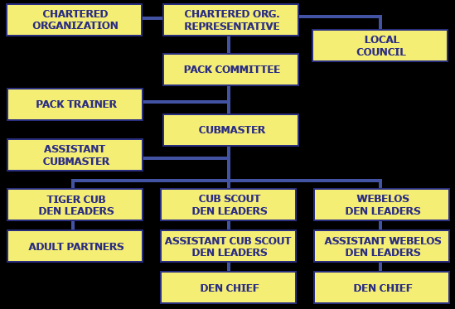

The Pack Chain of Command

We want to be a “together” Pack 510, Sometimes there can be conflicts
Should the need arise, please communicate through the following channels as described in the chart. Not following the order is disrespectful, and it is not setting a good example for our scouts.

- Parents should go to the Den Leader and try to solve a problem
- Den leader solves problem within the den or goes to Cubmaster

- The Cub Master is the Unit Leader and should solve most problems
- The Cub Master goes to Committee Chair if necessary.
- The Committee Chair Decides on own without a vote from Cubmaster or committee.
- The Committee Chair goes to the Pack Committee and if still not solved the Committee Chair goes to the Charter Organization Representative.
- Charter Organizational Representative. Goes to the Cogioba District Executive.
- Cubmaster reports back from committee and DE with decision.

At no time will a Parent or Leader within Pack 510 call anyone from Middle Tennessee Council Headquarters without first talking with the Committee Chair and or Cubmaster. If you do not get a reply from them your next step is to contact the Pack Charter Organizational Representive (COR).

2019 -2020 Planned Events
These are all subject to change due to weather or other circumstances
September
Sept 2 – Labor Day NO Cub Scout Meeting today
Sept 5 - Roundtable at 7pm, 150 Richview Rd. For Cub Scout Leaders
Sept 9 – Pack meeting Roundup
Sept 11 – Patriots Day 911
Sept 16 – No Meeting
Pop Corn Fundraiser begins
Sept 21 - Welcome Home Veterans Parade
Sept 23 - No Meeting
Sept 30 – Pack Meeting 6pm Barkers Mill Cafeteria – Recharter begins, bring your annual membership fee
Sept 27-29 – OWLS - Outdoor Leader skills Training -Tennessee City
October
Oct 3 – Roundtable Cub Scout Leaders Meeting 150 Richview Rd.
Oct 5 - Cub Leader Basic and BALOO 8am – 4pm, Sango United Methodist Church, 3301 Sango Rd, Clarksville
Oct 12 – Cub Scout Bobcat Day from 1 to 4pm Hilldale UMC
Oct 14 to 18 – NO SCHOOL FALL BREAK - NO SCOUT MEETINGS
Oct 21 – Pack Meeting – Halloween Party
Oct 25 - 27 Cogioba District Cub and family Campout week 4, weekend – Boxwell
Oct 31 – Halloween
November
Nov 7 – Roundtable Adult Leader Meeting 7pm 150 Richview Rd. For Cub Scout Leaders
Nov 9 – Veterans Day Parade - 830am – 11:30
Nov 11- Veterans Day – NO SCHOOL – NO PACK DEN MEETINGS
Nov 18 – Pack Meeting 6pm
Nov 28 – Thanksgiving Day
December
Dec 5 – Roundtable Leaders Training 7pm
Dec 16 – Pack Meeting – Pack Christmas / Holiday Party
Dec 23 – 6 Jan 2020 WINTER BREAK, NO SCHOOL, NO SCOUTS
January
Jan 2- Roundtable Leaders training
Jan 13 – First Pack/Den meetings of the 2020 year
Jan 21 Dr Martin Luther King Day NO SCHOOL NO SCOUTS
TBD Campout
February
Feb 2 blue and gold AOL Crossover
4 Chaplin’s Ceremony
Feb 17- President’s Day NO SCHOOL NO SCOUTS
Feb 16 - Pack 510 Pinewood derby
March
Mar 1-3 District Pinewood Derby
Mar 23-27 Spring Break NO SCHOOL, NO SCOUTS
April

May
TBD Pack activity
June
TBD - Pack activity
July
TBD - Pack activity

This calendar is subject to change and is to use as a general guide for the activities planned for the 2019-20 year.

Rank Advancement
During the Cub Scout Experience every cub scouts’ advances in Rank each year as long as they complete all the requirement and are active in the pack. All rank advancement requirements are new as of 2019 – 2020 scouting year. Please see the handbook for specific rank requirements and completing the new “adventure system”

Bobcat | Required for every Cub Scout to earn regardless of when they start with the program, contains learning the basics of the Scout Oath, and Law
Lion | Kindergarten
Tiger | 1st Grade
Wolf | 2nd Grade
Bear | 3rd Grade
Webelos | 4th Grade
Arrow of Light | 5th Grade – “Webelos 2”

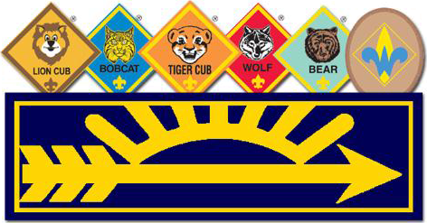

The Road to Bobcat your Scouts first work
Scout parents here is a work sheet for you to work with your scout for him/her to obtain their first achievement of Bob Cat. Once you have completed theses 6 goals Initial each one and turn this form into your Den Leader or Cubmaster.
